Chapter 16, Solution 71.

For the ideal transformer circuit in Fig. 16.94, determine i_{o}(t).

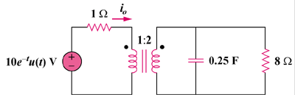

Figure 16.94
For Prob. 16.71.

Solution

Consider the following circuit.

8

4/s

1

10/(s + 1)
+

I_{o}

1 : 2

Let

When this is reflected to the primary side,

,

which leads to i_{o}(t) = 10[2e^{–1.5t} – e^{–t}]u(t) A

